SCHEDULE 2 – THE SERVICES

- Service Specifications

Service Specification No. | MAS2023-24
Service | Minor Ailments Service
Commissioner Lead | Julie Dandridge, Buckinghamshire, Oxfordshire and Berkshire West Integrated Care Board (BOBICB)
Provider Lead | David Dean, Community Pharmacy Thames Valley
Period | 1 December 2023 to 31 March 2024
Date of Review | March 2024

1. Population Needs
General Overview

1.1 National/local context and evidence base
Minor ailments are defined as common or self-limiting or uncomplicated conditions which can be managed without medical intervention. The management of patients with minor self-limiting conditions, impacts significantly upon GP workload. The situation is most acute where patients do not pay prescription charges and may not have the resources to seek alternatives to a prescription from their GP. It is estimated that one in five GP consultations are for minor ailments and by reducing the time spent managing these conditions would enable them to focus on more complex cases.

2. Outcomes
2.1 NHS Outcomes Framework Domains & Indicators

Domain 1 | Preventing people from dying prematurely
Domain 2 | Enhancing quality of life for people with long-term conditions
Domain 3 | Helping people to recover from episodes of ill-health or following injury | X
Domain 4 | Ensuring people have a positive experience of care | X
Domain 5 | Treating and caring for people in safe environment and protecting them from avoidable harm | X

2.2 Local defined outcomes
- To improve patient’s access to advice and medication for an agreed list of minor ailments for patients/families on low income.
- To reduce the number of patients having to attend their local GP, ED or local urgent care services.
- Improve working relationships between GPs and Pharmacists
- Provide evidence-based care in line with national and local guidelines.

3. Scope
3.1 Aims and objectives of service
3.1.1 To improve access and choice for people with minor ailments by:
- Promoting self-care through the pharmacy, including provision of advice and where appropriate medicines without the need to visit the GP practice.
- Operating a referral system from local medical practices or other primary care providers.
- Supplying appropriate medicines at NHS expense for those who are eligible.
- To link with the Community Pharmacy Consultation Service (CPCS) to enable access to treatment for patients/families on low income.

3.1.2 To improve primary, urgent and emergency care capacity by reducing medical practice workload related to minor ailments.
3.2 Service description
3.2.1 The overall aim of the scheme is to ensure that patients can access self-care advice for the treatment of minor ailments and, where appropriate, can be supplied with medication (at NHS expense as long as patient is exempt), to treat their ailment. This provides an alternative location from which patients can seek advice and treatment, rather than seeking treatment via a prescription from their GP or out of hours (OOH) provider, or via a walk-in centre or accident and emergency.
3.2.2 This service is being commissioned by Buckinghamshire, Oxfordshire and Berkshire West Integrated Care Board (BOB ICB) and the service will be regularly reviewed, and BOB ICB will retain any rights to amend or cancel the service with 1 months’ notice to the pharmacy.
3.2.3 Pharmacies included in the scheme will provide advice and support to people on the management of minor ailments, including where necessary, the supply of medicines for the treatment of the minor ailment (Appendix 2)
3.2.3 The services will be available to all patients who request a consultation and for a minimum of 80% of the total weekly opening hours.
3.2.4 If the pharmacy for whatever reason cannot provide the service, then the patient should be directed to the nearest pharmacy that can.
3.2.5 The pharmacy should inform the commissioner if they are unable to provide the MAS for an extended period (defined as 1 week or more) due to any circumstances.
3.2.6 If the pharmacy wishes to withdraw from the scheme, 1 months’ notice must be given to the commissioner.
3.2.7 Should any products on the formulary be unavailable the Pharmacy should notify the ICB with estimated availability date if possible.
3.3 Service outline
3.3.1 The Minor Ailments service should be delivered by a pharmacist or by support staff trained to the GPhC standards for Medicines Counter Assistants acting under the supervision of a pharmacist. The pharmacist must be aware of the consultation and able to intervene or approve the outcome of the consultation if necessary.

3.3.2 The pharmacy contractor has a duty to ensure that pharmacists and staff, including regular locums, involved in the provision of the service have relevant knowledge and are appropriately trained in the operation of the service.

3.3.4 The pharmacy contractor has a duty to ensure that all pharmacy staff understand that this service is not intended to divert patients presenting in the pharmacy with a minor ailment listed on the minor ailment service. This service should only be offered to those who would usually consult the GP, out of hours, NHS 111 service, Minor Injury Unit, ED services for minor ailments, or have been referred via the Community Pharmacy Consultation Service (CPCS)

3.3.5 Patient eligibility – please see section 3.4 and 3.5

3.3.6 The pharmacist/staff member will provide advice on the treatment of minor ailments to people seeking such advice in the pharmacy for themselves or their children. Patients may be supplied with appropriate medicine(s) from the MAS formulary (Appendix 1). The items listed in the formulary can be provided through the scheme for any condition covered by their Over the Counter (OTC) licence. The quantity of medicinal treatment supplied should be sufficient to treat only the current episode and not for preventative or ‘in-case’ scenarios. The bar code on the product being supplied must be crossed through with an indelible pen and mark the pack clearly with the words ‘NHS supply’.
3.3.7 The pharmacist or member of staff must be satisfied that the patient is currently suffering from the condition/symptoms described and that treatment is required. Under no circumstances may a supply be given for future use or ‘in-case’ scenarios
3.3.8 The part of the pharmacy used for provision of the service provides a sufficient level of privacy and safety and meets other locally agreed criteria. If a consultation room is available, patients will be offered the opportunity of the consultation taking place within it. The pharmacist must be aware if a staff member is using the consultation room, so that they can check the outcome of the conversation

3.3.9 The pharmacy has a system to check the person’s eligibility for receipt of the service in line with the usual checks on NHS prescriptions and record via PharmOutcomes.

3.3.10 The pharmacy contractor must maintain appropriate records to ensure effective ongoing service delivery and audit. This will include recording the consultation and any medicine that is supplied on PharmOutcomes.

3.3.11 If a patient presents more than twice within any month with the same symptoms and there is no indication for urgent referral, the pharmacist should consider referring the patient to their GP.
3.3.12 If the patient presents with symptoms outside the Minor Ailments service the patient should be treated in line with usual practice.
3.4 Population covered
3.4.1 This service is available to any person or their dependents (e.g., children), who are:

- on low income – please see link and below https://psnc.org.uk/wp-content/uploads/2018/08/PSNC-Briefing-040.18-Dispensing-Factsheet-Exemptions-from-the-prescription-charge.pdf
  - HC2 Charges Certificate – Possession of a valid HC2 Charges Certificate
  - Income Support (IS) – Possession of an IS award notice
  - Income-related Employment and Support Allowance (ESA) – Possession of an ESA award notice
  - Income-based Jobseeker’s Allowance (JSA) – Possession of a JSA award notice
  - Universal Credit (UC) – Possession of a Universal Credit statement
  - NHS Tax Credit Exemption Certificate – Possession of a valid Tax Credit Exemption Certificate
  - Pension Credit Guarantee Credit (PCGC) – Possession of a PCGC award notice
And
- registered with GP practice within the BOB ICB area
- who would otherwise have visited a GP, OOH, NHS 111, Minor Injury Unit, ED or has been referred via the Community Pharmacy Consultation Service (CPCS)

3.4.2 The patient must be in attendance; the service cannot be carried out if the patient is absent. In the case of a child under 16, the parent or guardian must be in attendance, but the child being treated need not be present.

3.5 Any acceptance and exclusion criteria and thresholds
3.5.1 Patients will either self-refer into the service or will be referred by their GP

3.5.2 It is not a service intention to divert patients presenting in the pharmacy with a minor ailment. People who usually manage their own minor ailments through self-care and the purchase of an OTC medication should continue to self-manage and treat their minor ailments as per Essential Service 6 Support for Self-Care.

3.5.3 For patients who do not meet the service criteria, the pharmacy may provide advice and sell OTC medicines to the person to help manage the minor ailment, as described in Essential Service 6 Support for Self-Care.

3.6 Interdependence with other services/providers
3.6.1 The Provider shall ensure that effective and clear communication is maintained with patients and GP surgeries.
4. Applicable Services Standards
4.1 Applicable national standards
4.1.1.National Pharmaceutical Contractual Framework, with particular reference to Essential Services specification for Support for Self-care and Signposting.

4.1.2. Both parties shall adhere to the requirements of the Data Protection Act 1988 and Freedom of Information Act 2000

4.2 Applicable standards set out in Guidance and/or issued by a competent body (eg Royal Colleges)
Standards provided by the GPhC.

4.3 Applicable local standards
4.3.1 The pharmacist will identify any concurrent medication or medical conditions which may affect the treatment of the patient.
4.3.2 The pharmacist will consider past medication supplied for the minor ailment to assess appropriateness of further supply.
4.3.3 There is no requirement to label the OTC product although pharmacies may wish to record the supply on the PMR in line with good practice guidelines.
4.3.4 Pharmacies and their staff are reminded of their existing obligations to comply with local and national guidance relating to child protection and safeguarding vulnerable adult procedures.

4.3.5 The Pharmacy shall maintain adequate insurance for public liability and professional indemnity against any claims which may arise out of the terms and conditions of this agreement.

4.3.6 Any resulting litigation resulting from an accident or negligence on behalf of the Pharmacy is the responsibility of the Pharmacy who will meet the costs and any claims for compensation , at no cost to BOB ICB.

5. Applicable quality requirements
  - Applicable quality requirements

5.1.1 The pharmacy has appropriate commissioner provided health promotion and self-care material available for the user group and promotes its uptake.
5.1.2 The pharmacy participates in any commissioner organised audit or post payment verification of service provision.
5.1.3 The pharmacy should co-operate with any commissioner-led assessment of patient experience.
5.1.4 The pharmacist ensures that clinical advice given is in line with national/local guidelines.
5.1.5 The pharmacist ensures that any patient incidents that occur are reported via their normal pathway.
5.1.6 The pharmacist ensures that the pharmacy has a complaints procedure in place that meets the NHS pharmaceutical contractual standards.
5.1.7 The pharmacist and staff actively promote the service to those patients who would normally access treatment for minor ailments from their GP.

Appendix 1 - Formulary
Only medicines from the formulary can be used for treatment under the Minor Ailments Scheme (MAS). These products can be used for any of their licensed indications at licensed doses. Pharmacists can supply any brand of product as long as the active ingredients are the same and pack size is at least the size specified (e.g., larger packs can be supplied) but payment will be in line with DM&D prices. The products supplied must not be POM packs and each product must be supplied with a corresponding Patient Information Leaflet.
The pharmacist making the supply is professionally accountable for the treatment decisions made.

Ailment | Product
Respiratory System
Allergies | Chlorphenamine 2mg/5ml SF Liquid (1 x 150ml)
 | Cetirizine tablets (1 x 30)
 | Sodium cromoglycate 2% eye drops (1 x 10ml)
Pain
 | Paracetamol 120mg/5ml SF paed suspension (1x100ml)
 | Paracetamol 250mg/5ml SF suspension (1 x 100ml)
 | Ibuprofen 100mg/5ml SF suspension (1 x 100ml)
 | Paracetamol 500mg tablets (1 x 32)
 | Ibuprofen 200mg tablets (1 x 24)
Skin
Athlete’s Foot & Ringworm | Clotrimazole 1% cream (1 x 20g)
Contact Dermatitis & Eczema | Hydrocortisone 1 % cream (1 x 15g)
Head Lice | Metal detection comb Nitty Gritty NitFree (1 if not included in box below)
 | Dimeticone Lotion 4% (enough for 2 treatments)
Oral thrush | Miconazole oral gel 20mg/g (Daktarin) (1 x 15g)
Vaginal Thrush
 | Clotrimazole 2% cream (1 x 20g)
 | Clotrimazole 500mg pessary (x1)
 | Fluconazole 150mg capsule (x1)
Eye
Conjunctivitis | Chloramphenicol 0.5% eye drops (1 x 10ml)
Other
Threadworm | Mebendazole 100mg (Ovex single dose) tablet (x1)
 | Mebendazole 100mg/5ml (Ovex) oral suspension (1 x 30ml)

Appendix 2: Minor Ailments Scheme - Service Guide
Patient Eligibility
- Registered with a GP Surgery in the BOB ICB area
- Adults exempt from prescription charges (evidence shown) or children of adults exempt from prescription charges
- Present in the pharmacy (for a child under 16, parent or guardian must also be present)
- If the patient cannot attend the pharmacy the pharmacist must use their professional judgment to assess if a supply should be made
- Currently suffering from a minor ailment that can be treated using an item from the formulary

Minor Ailment Consultation
- Consultation room should be offered
- Use consultation form or input direct to PharmOutcomes
- Discuss nature and duration of symptoms
- Concurrent medication and medical conditions
- Exclusion of serious disease/alarm/red flag symptoms

Treatment Decision
- Advice only
- Advice and supply of medication
- Sign posted to GP for non-urgent appointment, with or without supply of medication where appropriate
- Urgent referral
Advice
- Expected duration of symptoms – what’s normal duration etc.
- Self- care messages
- What patients can do for themselves
- Provide service information stressing importance of making pharmacy first port of call for minor ailments
- When and where to go for further advice and the management of future minor ailments
- Anti-biotic use messages
- Provide printed information where appropriate

Medication supply & Record
- Supply medication only if necessary
- Select medication from formulary, score barcode
- Advise on how medication works, side effects, cautions etc.
- Record on PharmOutcomes

Treatment Decision
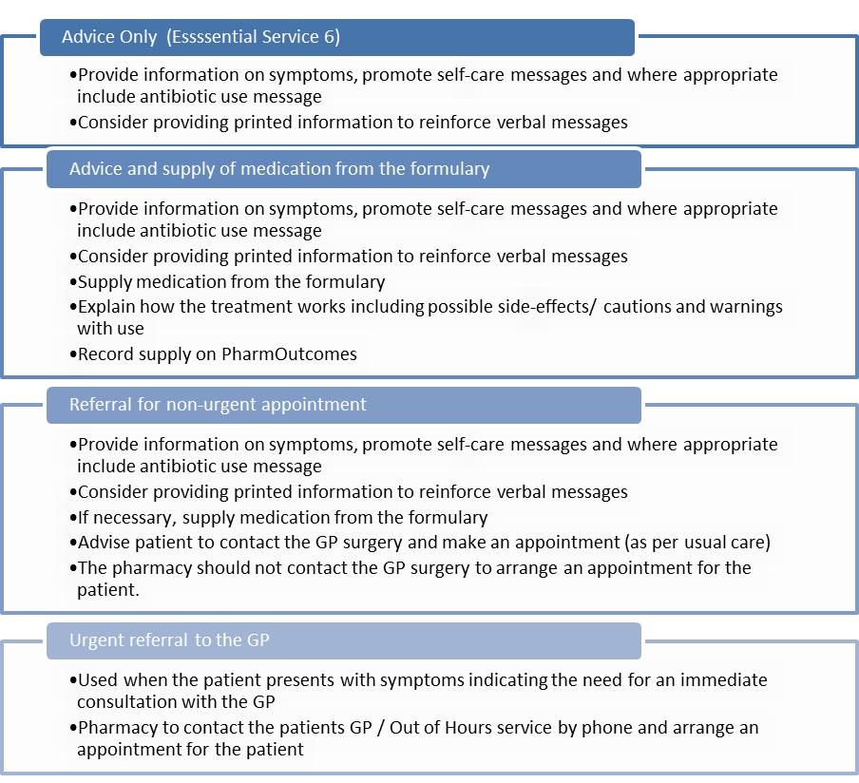
Appropriate use of antibiotic’s message
- Discuss with the patient the key messages about antibiotics not being required for minor infections, such as coughs, colds, earache, sinusitis, flu, sore throat and diarrhoea, because these are usually caused by viruses.
- Discuss possible side effects of antibiotics, and problems caused by resistance.

Although the pharmacist should not make GP appointments on behalf of the patient, if they feel the patient has worrying symptoms, and is concerned the patient will not make an appointment or will not explain the symptoms clearly, the pharmacist can phone and speak directly to the patients GP for advice.
Note: Pharmacies are only paid a consultation fee under the scheme when medication is supplied. Pharmacists are contractually obliged to provide advice or signpost patients onwards as part of their standard NHS Contract Funding under essential service 6. Pharmacies should only provide medication where there is a clinical need. Providing unnecessary medication would be against the agreement of this scheme and professional standards.
The patient can have a maximum of 2 products per consultation. The product barcode should be crossed though, and the product clearly marked “NHS Supply”
The pharmacist must maintain a record of the supply and consultations by promptly recording on PharmOutcomes. This ensures live audit for commissioners and prompt payment for pharmacy. Pharmacies who require further information on the use of PharmOutcomes should contact the help desk team via the help tab at http://pharmoutcomes.org.

Payment- Claims
For consultations where a medication is supplied, the pharmacy will be paid £6.00 (including VAT) to include;
  - Set up costs (SOP development, staff training etc.)
  - Staff time to provide the service
  - Completing PharmOutcomes information

Where a patient is eligible for free provision of treatment then medicines from the formulary (Annex 1) may be provided free of charge. Pharmacies will be reimbursed for the drugs they supply at the Drug Tariff price, or where this is not available the Chemist and Druggist trade price, for the appropriate calendar month plus VAT.
Where some items on the formulary are in shortage, and a concessionary price has been introduced as the tariff price is out of sync, it could be possible to retrospectively reimburse the concession price if published instead of the tariff price and there is a significant variation in price.
Payments will be made based on the information recorded on PharmOutcomes. Payment will be made to pharmacies on a monthly basis via NHSBSA and will show as LS1 on your statement. Post-payment verification checks may be conducted for each pharmacy and can be made using PharmOutcomes or may require a visit to the pharmacy.

Standard Operating Procedure (SOP)
The pharmacy should have a SOP in place for all the services the pharmacy provides, including the Minor Ailments Service. SOPs are necessary to demonstrate to commissioners that the pharmacy is meeting the requirements of the service and to ensure that the service is provided in a safe and consistent manner.
An SOP should:
- Define staff roles and responsibilities
- Include any relevant signposting information.
- Include the process for error and near miss reporting.
- Be regularly reviewed and kept up to date.
- Be signed and dated by all staff (including locums) operating under the SOP.
- State the date of production and review date.

Check with the Superintendent before you write any SOP because they are ultimately responsible for its content.

Key Cotacts
Contacts | Details
BOB ICB Pharmacy, Optometry and Dentist Team | bobicb.pod.services@nhs.net
Community Pharmacy Thames Valley | chiefofficer@cptv.org.uk  cso@cptv.org.uk

