No Smoking Day 2026 Communications toolkit - Supporting people to quit for good.
11th March 2026

Campaign overview
No Smoking Day 2026 is an important opportunity for Buckinghamshire partners to accelerate progress towards a smokefree population. The campaign uses clear, evidence-based messages and proven tools, including the NHS Quit Smoking App and Personal Quit Plan, which help to motivate residents by highlighting the rapid physical and mental health benefits of quitting.
Why it matters:
Smoking remains the leading preventable cause of ill health and premature death, and it significantly contributes to health inequalities across society. Nationally, one in two smokers will die from a smoking related disease. In Buckinghamshire, an estimated 8.3% of adults smoked in 2024. While smoking prevalence has declined over time, approximately 1 in 12 residents continue to smoke, highlighting the ongoing need for effective cessation.
Role and impact of the campaign:
The campaign strengthens routes into local stop smoking services and provides ready to use content to ensure consistent messaging across workplaces, community venues, and health settings. A coordinated approach will help increase quit attempts, reduce health inequalities, support progress towards Smokefree 2030, easing pressure on health and care services, and improve residents’ wellbeing and financial resilience.

1. Key messages
- Quitting improves mental and physical health, often within weeks.
- You know you want to quit. We know you can.
- It’s well worth it!
- Everyone deserves the chance to live smokefree.
- Free support and tools can make quitting easier and more successful.
- It’s never too late to stop smoking.

2. Campaign assets and how to use
Asset type | Action | Suggested wording/messaging | Resources
Personal Quit Plan | Share the graphic and QR code | “A personal quit plan gives you tailored steps to help you quit with confidence. Answer a few quick questions and get personalised, evidence-based support.” | Personal Quit Plan Asset  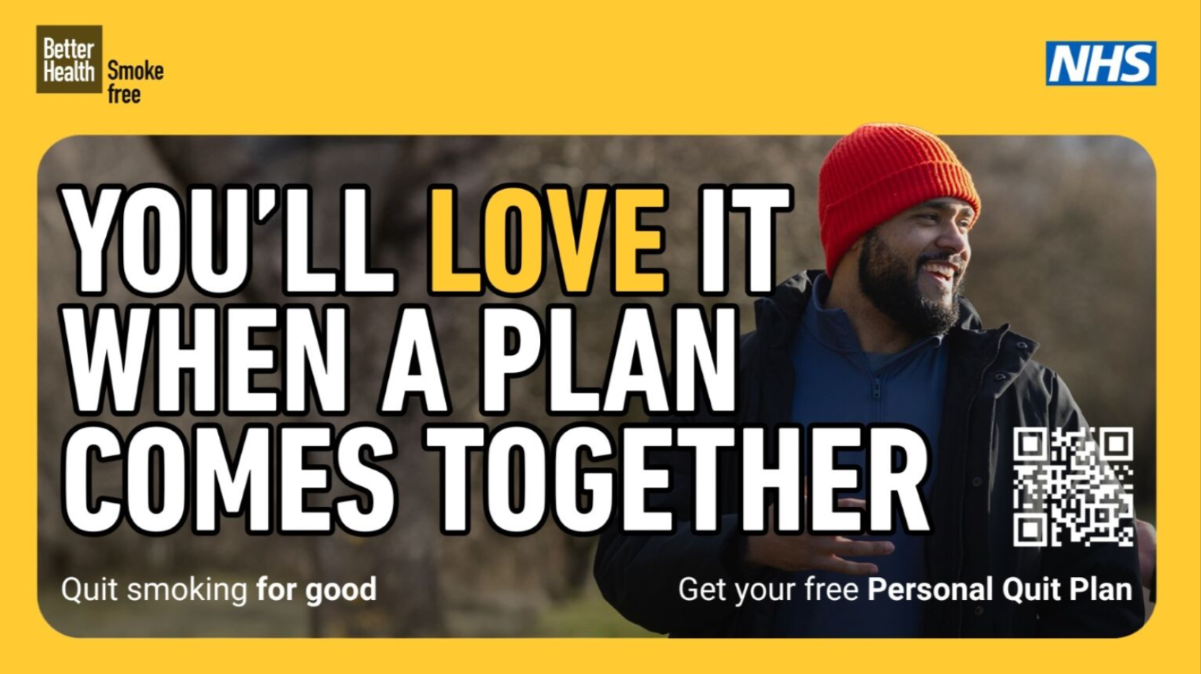
NHS Quit Smoking App | Use app graphics and display the QR code wherever | Stay motivated with the free NHS Quit Smoking App. Track your cravings, celebrate smokefree days, and see the health and money benefits grow. | National NSD 2026 asset (NHS with QR code)  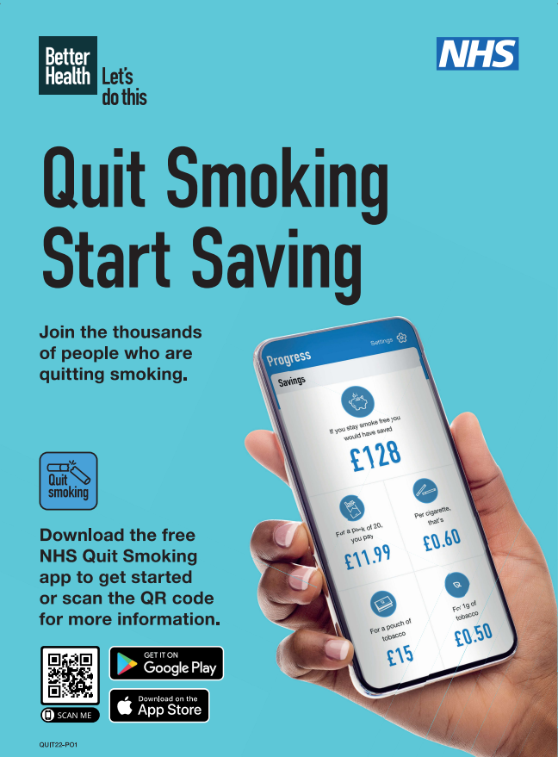
Mental health & wellbeing resources | Share the Southeast regional campaign posters (Posters 1 & 2). | Stopping smoking can reduce stress, anxiety, and low mood within weeks. Many people report feeling calmer and more in control after quitting. Support is available for anyone who wants help on their quit journey.  Key messages:  - Stopping smoking can reduce stress, anxiety, and low mood within weeks.  - Many people report feeling calmer and more in control after quitting.  - Support is available for anyone who wants help on their quit journey. | South East Smokefree Alliance poster 1 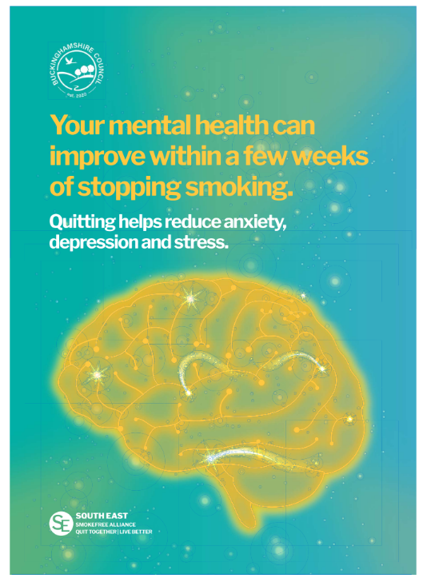  South East Smokefree Alliance Poster 2  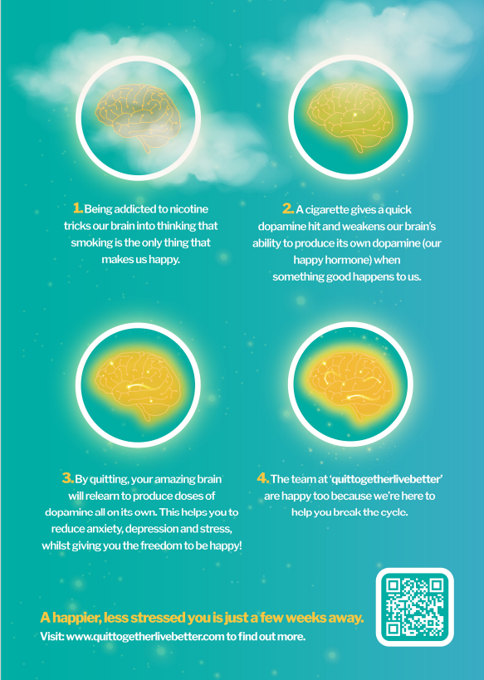
Local stop smoking support | Promote local services using provided assets and leaflets. | Free, friendly, and effective stop smoking support is available locally. Whether you’re trying to quit for the first time or returning after previous attempts, trained advisors can help you build confidence, manage cravings, and stay on track. | Local stop smoking service leaflet (Be Healthy Bucks)  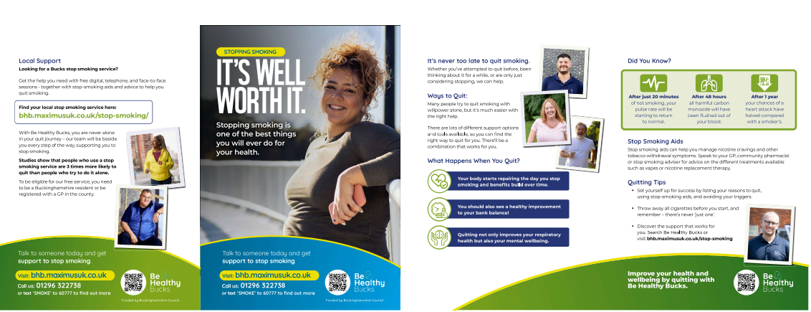  Local NSD 2026 asset 2 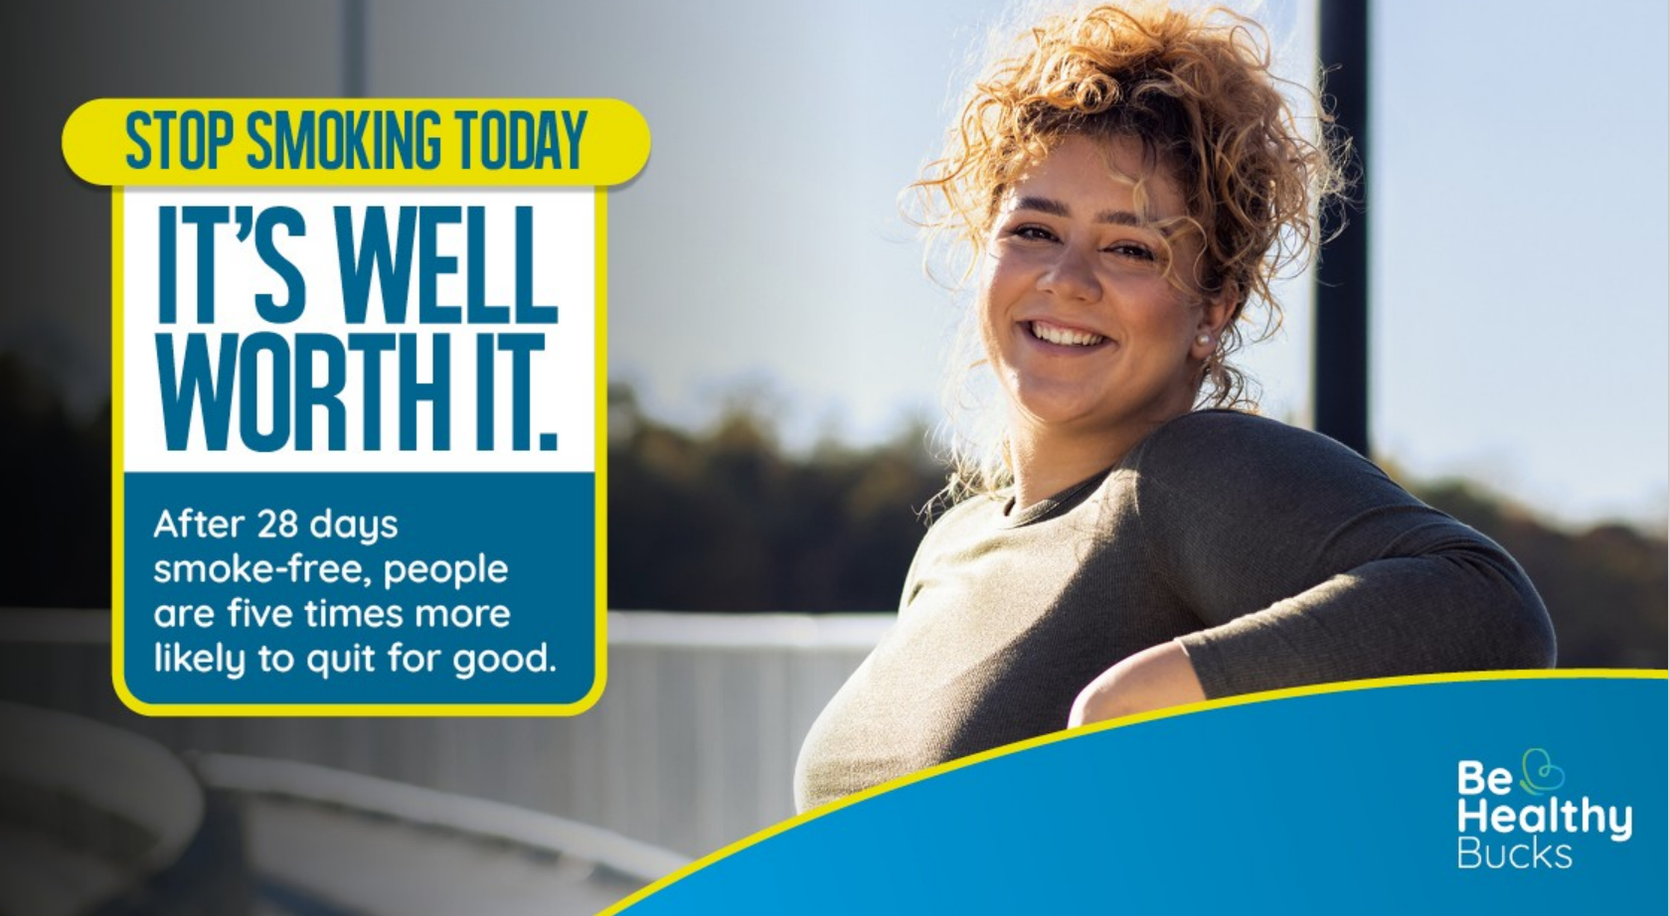  Local NSD 2026 GP DIGITAL screens 1 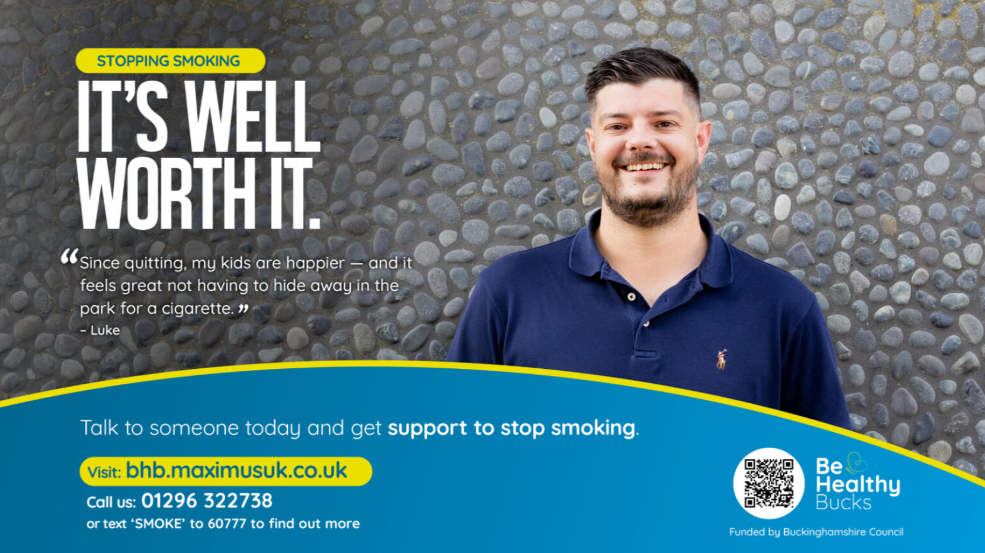  Local NSD 2026 DIGITAL screens 2  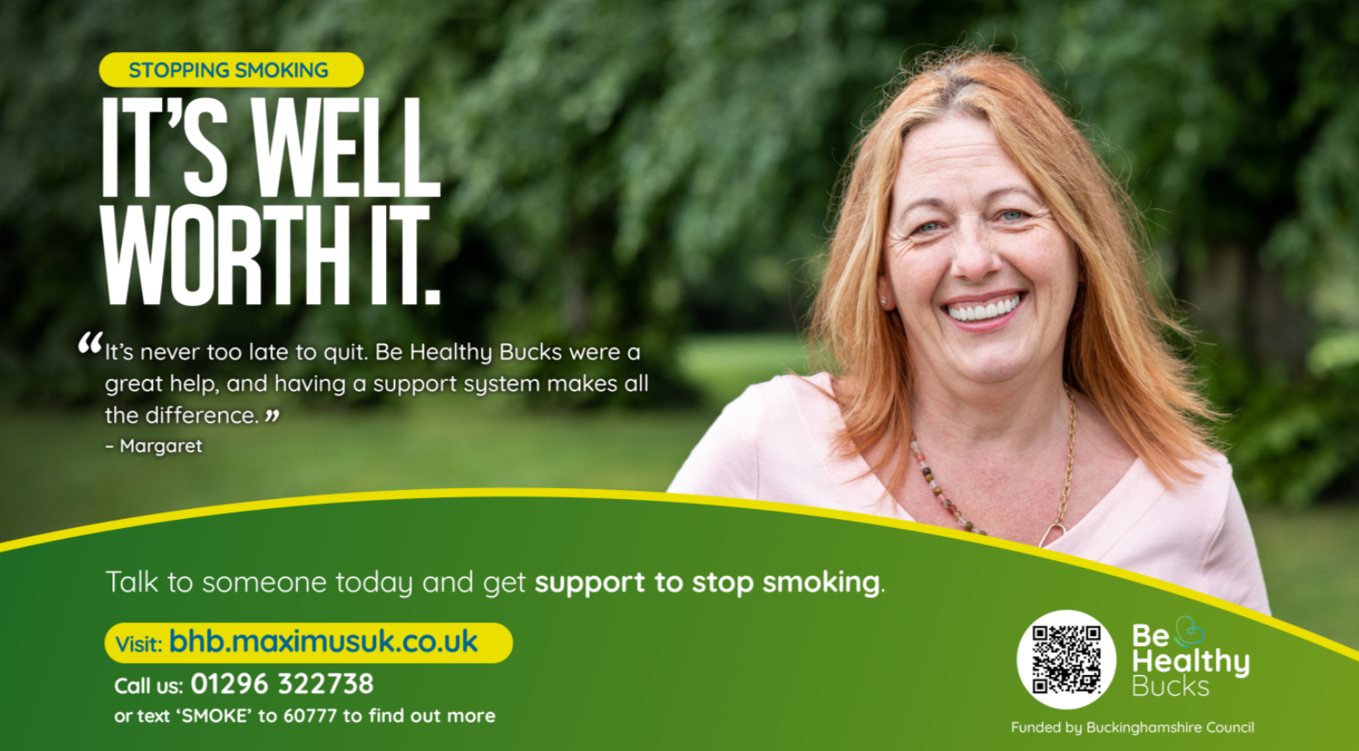
Ready-to-use social media posts | Share across all platforms during the No Smoking Day campaign. | Post 1: Beat the cravings and count the savings. Download the free NHS Quit Smoking App and take your first smokefree step.  Post 2: A plan makes quitting easier. Get your free NHS personal quit plan today.  Post 3: Quitting can improve mental health in just a few weeks. Free support is here to help you get started.  Post 4: Thinking about quitting? You’re not alone. Free tools and local support can help you succeed this No Smoking Day. | Use appropriate assets

3. Suggested actions by setting

a. Workplaces
Actions:
- Display posters in staff areas and communal spaces.
- Use digital screensavers or intranet banners.
- Add short quit messages to staff newsletters.

b. Community venues
Actions:
- Display posters in high footfall areas.
- Share QR code posters or leaflets.

c. Health & care providers
Actions:
- Use waiting room screens for national and local assets.
- Display QR code posters in reception and consulting areas.
- Encourage brief conversations about quitting (very brief advice).

